**SAVE OUR SWAN**

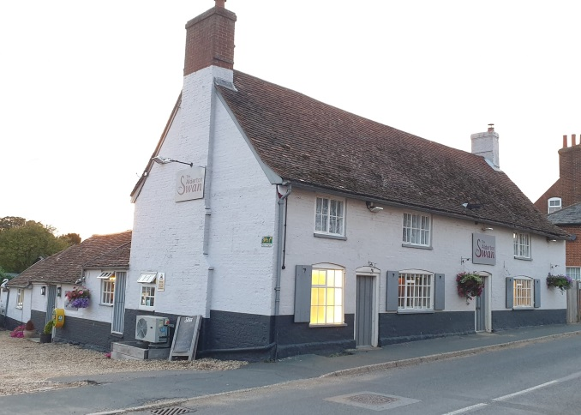

**COMMUNITY PUB INTEREST QUESTIONNAIRE**

As you are aware **The Alderton Swan** has been closed since Christmas Eve 2019. For most villages a pub is a vital service; it is a meeting place, communication centre and an important lynchpin of village life. Much of the appeal of our village rests on its sense of community and the amenities within it. It is the reason many people have moved here and remain here. Making sure that the village retains its pub, we - ‘The Community Interest Working Group’ - feel would greatly enhance that community spirit.

The other thing to seriously consider is the impact on local house prices. There’s a lot of articles out there that suggest property values can decrease quite significantly in the absence of a good local pub, especially in rural areas. That’s not to say that a private buyer or developer won’t buy and invest in making it a great pub, which of course would be fantastic, but it’s a very real risk. A research report issued by the Plunkett Foundation suggests that local pubs owned by the community are thriving where as private enterprises are failing. You can review the 2019 report here;

<https://plunkett.co.uk/wp-content/uploads/PLUNKETT_BB_PUBS19_download2.pdf>

**This questionnaire is the first step. The purpose of this questionnaire is to:**

1. **Understand the community’s potential use of The Swan**
2. **To explore levels of interest in potential Community Funding**
3. **To determine further non financial support**

**We need to know your views on what might be provided and what would receive your support.**

Please be as honest and realistic as possible in your answers! Your response will be treated in confidence. **It is entirely anonymous**, unless you wish to add your name / address at the end (which will NOT be published in the final results).

**Once completed, please return the questionnaire in a sealed envelope to either the Alderton Stores, or to Tamarisk, The Street, Alderton, addressed to Mrs Christina Joyce by no later than**

**31st MARCH**

Further copies of this questionnaire can be located at the **Alderton Stores.**

[The results of this survey will also be published and a hard copy will also be available at the shop. ]

This kind of venture has been successfully achieved in other communities all over the UK and most of these have been set up with the support of the charity **“Plunkett Foundation”.** Will our community be the next one? If you wish to speak directly to someone about this project, please contact one of the following:

**MAL WARD - 07551 766718 (** [**mal@malward.co.uk**](mailto:mal@malward.co.uk)**) or**

**CHRISTINA JOYCE - 07776 305447 (** [cgm80@hotmail.co.uk](mailto:cgm80@hotmail.co.uk) )

**Community Pub Interest Questionnaire:**

**The Alderton Swan**

**About a community-owned pub for our community**

**1.How often did you use the pub and its related activities?**

Daily Comments

o 2-3 times a week

o Once a week

o Once a fortnight

o Occasionally

o Not at all

**2. On a scale of 1 – 5 (1 being no impact and 5 being the highest) how much has the closure of The Swan affected you and your family?**

1 2 3 4 5

**3. Do you want the Community to attempt to purchase the pub**?

Yes No

Comments

4**. If our local pub was saved and owned by the community, how often would you use it?**

**o** DailyComments:

o 2-3 times a week

o Once a week

o Once a fortnight

o Occasionally

o Not at all

5**. When are you most likely to use the pub? Tick all that apply**

Midweek [ ] Weekends [ ] Bank Holidays [ ]

6**. What time of day would you like to use the pub? Tick all that apply**

Coffee/Brunch 10.00 – 12 Lunchtime 12.00 – 15.00

Afternoon tea time 15.00 – 18.00 Early Evenings 17.00 – 21.00

Late Evening 21.00 – closing

7**. If we held weekly events in the pub (meet up Wednesdays, Knit and Natter, Book clubs etc) how frequently would you stay if we provided a meal special after these events?**

Very frequently (on most occasions) On occasion (maybe once or twice a month)

Infrequently Never

8**. What time of year are you more likely to use the pub? Tick all that apply**

Winter [ ] Spring [ ] Summer [ ] Autumn [ ]

9**. What would be your main reasons for using the pub? Tick all that apply**

Socialising with friends/family Special Occasions and celebrations

Entertainment (music nights) Sports Clubs or Club Venue (Darts, Book clubs)

Post recreation (cycling, walking) Other – please specify

10**. What services are you most interested if you were to visit the pub? Tick all that apply**

**Please rate them from 1 to 6 (1 being least interested 6 being most interested)**

Alcoholic beverages Traditional pub food

Non Alcoholic beverages Restaurant dining

Light bites Locally sourced food

Other – please specify

**11. When would you like to see food served?**

o Serving food isn’t important to me

o Weekday lunch

o Weekday dinner

o Saturday lunch

o Saturday dinner

o Sunday lunch

o Other

**12.** Are there any community services / activities you would like to see on offer at the pub? For example, after-school clubs, coffee mornings, book clubs, walking groups, pop-up health services, movie / cinema club etc. When and how would you like these services to be part of the pub’s offering?

**Comments:**

**13. What additional services would you most like to see the pub offer?**

o Family friendly + pet friendly areas o Parcel Collection Service

Function room o Local Art for sale/display in pub

o Games room o Pleasant and welcome atmosphere

o Catering (dinners and lunches) o Live music

o Televised Sports/Films/Shows o Drop-in sessions (educational, training, skills)

o Free Wifi (if possible!) o Fundraising for charities/good causes

o Locally sourced alcoholic beverages o Comfortable seating

o Cosy Fires o Affordable prices for beer and food

o Other (use the comments section)

**Comments**

**14.** On a scale of 1 – 5 (where 1 is not important and 5 is very important), how important do you think it is to have a local pub in Alderton?

**1 2 3 4 5**

**Comments**

**15. Please state how many people there are in each age range in your household:**

0-16 number of people: …………..

17 – 25 number of people:………...

26 – 45 number of people:…………

46 – 65 number of people:…………

over 65 number of people:…………

**16 . Would you or anyone in your household be interested in helping a co-operative pub project in any way by:**

o Helping with fundraising

o Providing professional advice/services and my profession/skills are……………………………………………………………………………………

o Be involved in running the pub/volunteering

o Making a donation (see next page)

o Buying a share (see next page)

o Making a loan (see next page)

o I would not be interested

**17. Is there anything else you believe we should be aware of, or you wish to add:**

**Community Pub Interest Questionnaire:**

**Pledge in Principle**

Whilst the Community Interest Group are in the very early stages of this project, we’re hoping to secure expert advice and financial support from the Plunkett Foundation ([www.plunkett.co.uk](http://www.plunkett.co.uk)).

The current aim is for enough funds to be raised for the community to buy the pub through grant funding, loans, donations and the community having the opportunity to buy shares.

Community shares will be backed by the value of the asset (the pub) and as finances permit may pay interest and be redeemable after a settling in period.

However, the group need an indication of potential shareholder investment to develop a detailed and costed community shares proposal and to understand whether there’s enough interest within the community to make this a financially viable project. If there’s little or no interest, sadly it’s likely that we won’t be able to continue with the project.

**NO MONEY OR FINANCIAL COMMITMENT IS NECESSARY AT THIS STAGE**

1. **In theory, once a detailed shares prospectus has been put together, what value of shares would you potentially be willing to invest in?**

o I would not be interested in purchasing shares

o £250 - £500

o £501 - £1,000

o £1,001 - £2,500

o £2,501 - £5,000

o £5,001 - £10,000

o £10,001 +

1. **Would you be willing to make a loan available or make a donation towards the purchase of the pub?**

Comments (please indicate a value of loan or donation)

o Neither

o Loan

o Donation

As stated previously, no money or financial commitment is needed at this stage, it is purely to help the community interest group to understand the level of interest in financially supporting the potential purchase. If you have indicated that you may be able to offer financial support, please provide contact details below. (This information will remain confidential to the community interest group members only).

**Name:**

**Address:**

**Phone:**

**THANK YOU VERY MUCH FOR TAKING THE TIME TO COMPLETE THIS QUESTIONNAIRE**