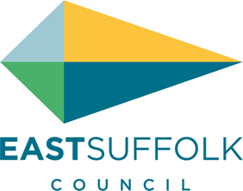

**July 2023**

Welcome to my monthly newsletter

Not much to report on polices and initiatives from the new administration but I hope very much they carry on the good work of the last four years . In particular I want to see the continued emphasis on our envrionment and communities - rural isolation , young and old - from transport to local services . Although there is much rhetoric about being an inclusive council I have not been asked for any handover from my environment dept or for that matter been asked to sit on any committees or represent East Suffolk on any outside bodies - it a strange old world politics .

I will however as normal continue to be your eyes and ears at the council and will continue to highlight our particular issues , rural isolation / litter / speeding vehicles / inappropriate planning applications

I have £7,500 community enabling grant to distribute across my ward so please do not hesitate to contact if you have any projects

In particular with my ( our ) interest in the environment I am always keen to support environment projects – establishing a pond , planting trees etc

Lots of fetes and events happening across the peninsula so I try and attend as many as possible - it’s is a good way to chat to residents and pick up on issues

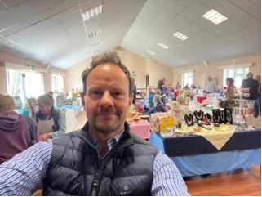

Attending the Sutton village hall craft morning

As this is my first newsletter of the new administration I just want to recap on some helpful council resources :

**Waste and Recycling**

|  |  |
| --- | --- |
| Household waste bin collection days | <https://my.eastsuffolk.gov.uk/service/Bin_collection_dates_finder> |
| Updates on waste collection delays | <https://www.eastsuffolk.gov.uk/assets/Waste/waste-collections-update.pdf> |
| Glass recycling Points | <https://suffolkrecycling.org.uk/where-to-recycle/glass-recycling> |
| Bring Site Points | <https://www.recyclenow.com/local-recycling> |

**Flytipping, litter and abandoned vehicles**

|  |  |
| --- | --- |
| Reporting a fly-tip or littering incident | <https://www.eastsuffolk.gov.uk/waste/fly-tipping/how-to-report-fly-tipping/> |
| Reporting an issue with a litter or dog litter bin (not emptied or broken / missing / vandalised) | <https://my.eastsuffolk.gov.uk/service/Bins___dog_waste_or_litter> |
| Community litter picks | <https://www.eastsuffolk.gov.uk/waste/litter/love-east-suffolk/> |
| Abandoned Vehicle reporting | <https://my.eastsuffolk.gov.uk/service/Abandoned_vehicle_or_roadside_issue> |

**Public realm and grounds maintenance**

|  |  |
| --- | --- |
| Reporting an issue with a public toilet | <http://my.eastsuffolk.gov.uk/service/public_toilets___report_a_problem> |
| Pardon the Weeds – areas of biodiversity | [Pardon-the-Weeds-campaign-information.pdf (eastsuffolk.gov.uk)](https://www.eastsuffolk.gov.uk/assets/Leisure/Parks-and-open-spaces/Grass-cutting/Pardon-the-Weeds-campaign-information.pdf) |
| Grass cutting FAQs | <https://www.eastsuffolk.gov.uk/assets/Leisure/Grass-cutting-FAQs.pdf> |
| Reporting an issue with a street name plate | [Report a damaged or missing street name plate - My East Suffolk](https://my.eastsuffolk.gov.uk/service/Street_name_plate___damaged_or_missing) |

And when we look at highways two important points :

**Suffolk county council liability**

If you car is damaged by Suffolk county council negligence in their upkeep of highways ( thinking pot holes here ) then you can make a claim :

<https://www.suffolk.gov.uk/roads-and-transport/highway-maintenance/making-a-highways-insurance-claim>

**Mud on highways from farming**

Section 148 of the Highways Act 1980 makes it an offence to deposit mud and other materials on the highway that would interrupt other users of the highway.

More information found : <https://www.nfuonline.com/updates-and-information/mud-on-the-roads-what-you-need-to-know/>

This is particularly a problem in spring and autumn and something we need to monitor

**James Mallinder**

**Deben Ward**

**A voice for parishes and residents of the Peninsula**